Royal Enfield gears up to take on the mighty Himalayas with the 15th edition of Himalayan Odyssey

~ Opens registrations for Himalayan Odyssey and Himalayan Odyssey Women on May 4th, 2018 ~

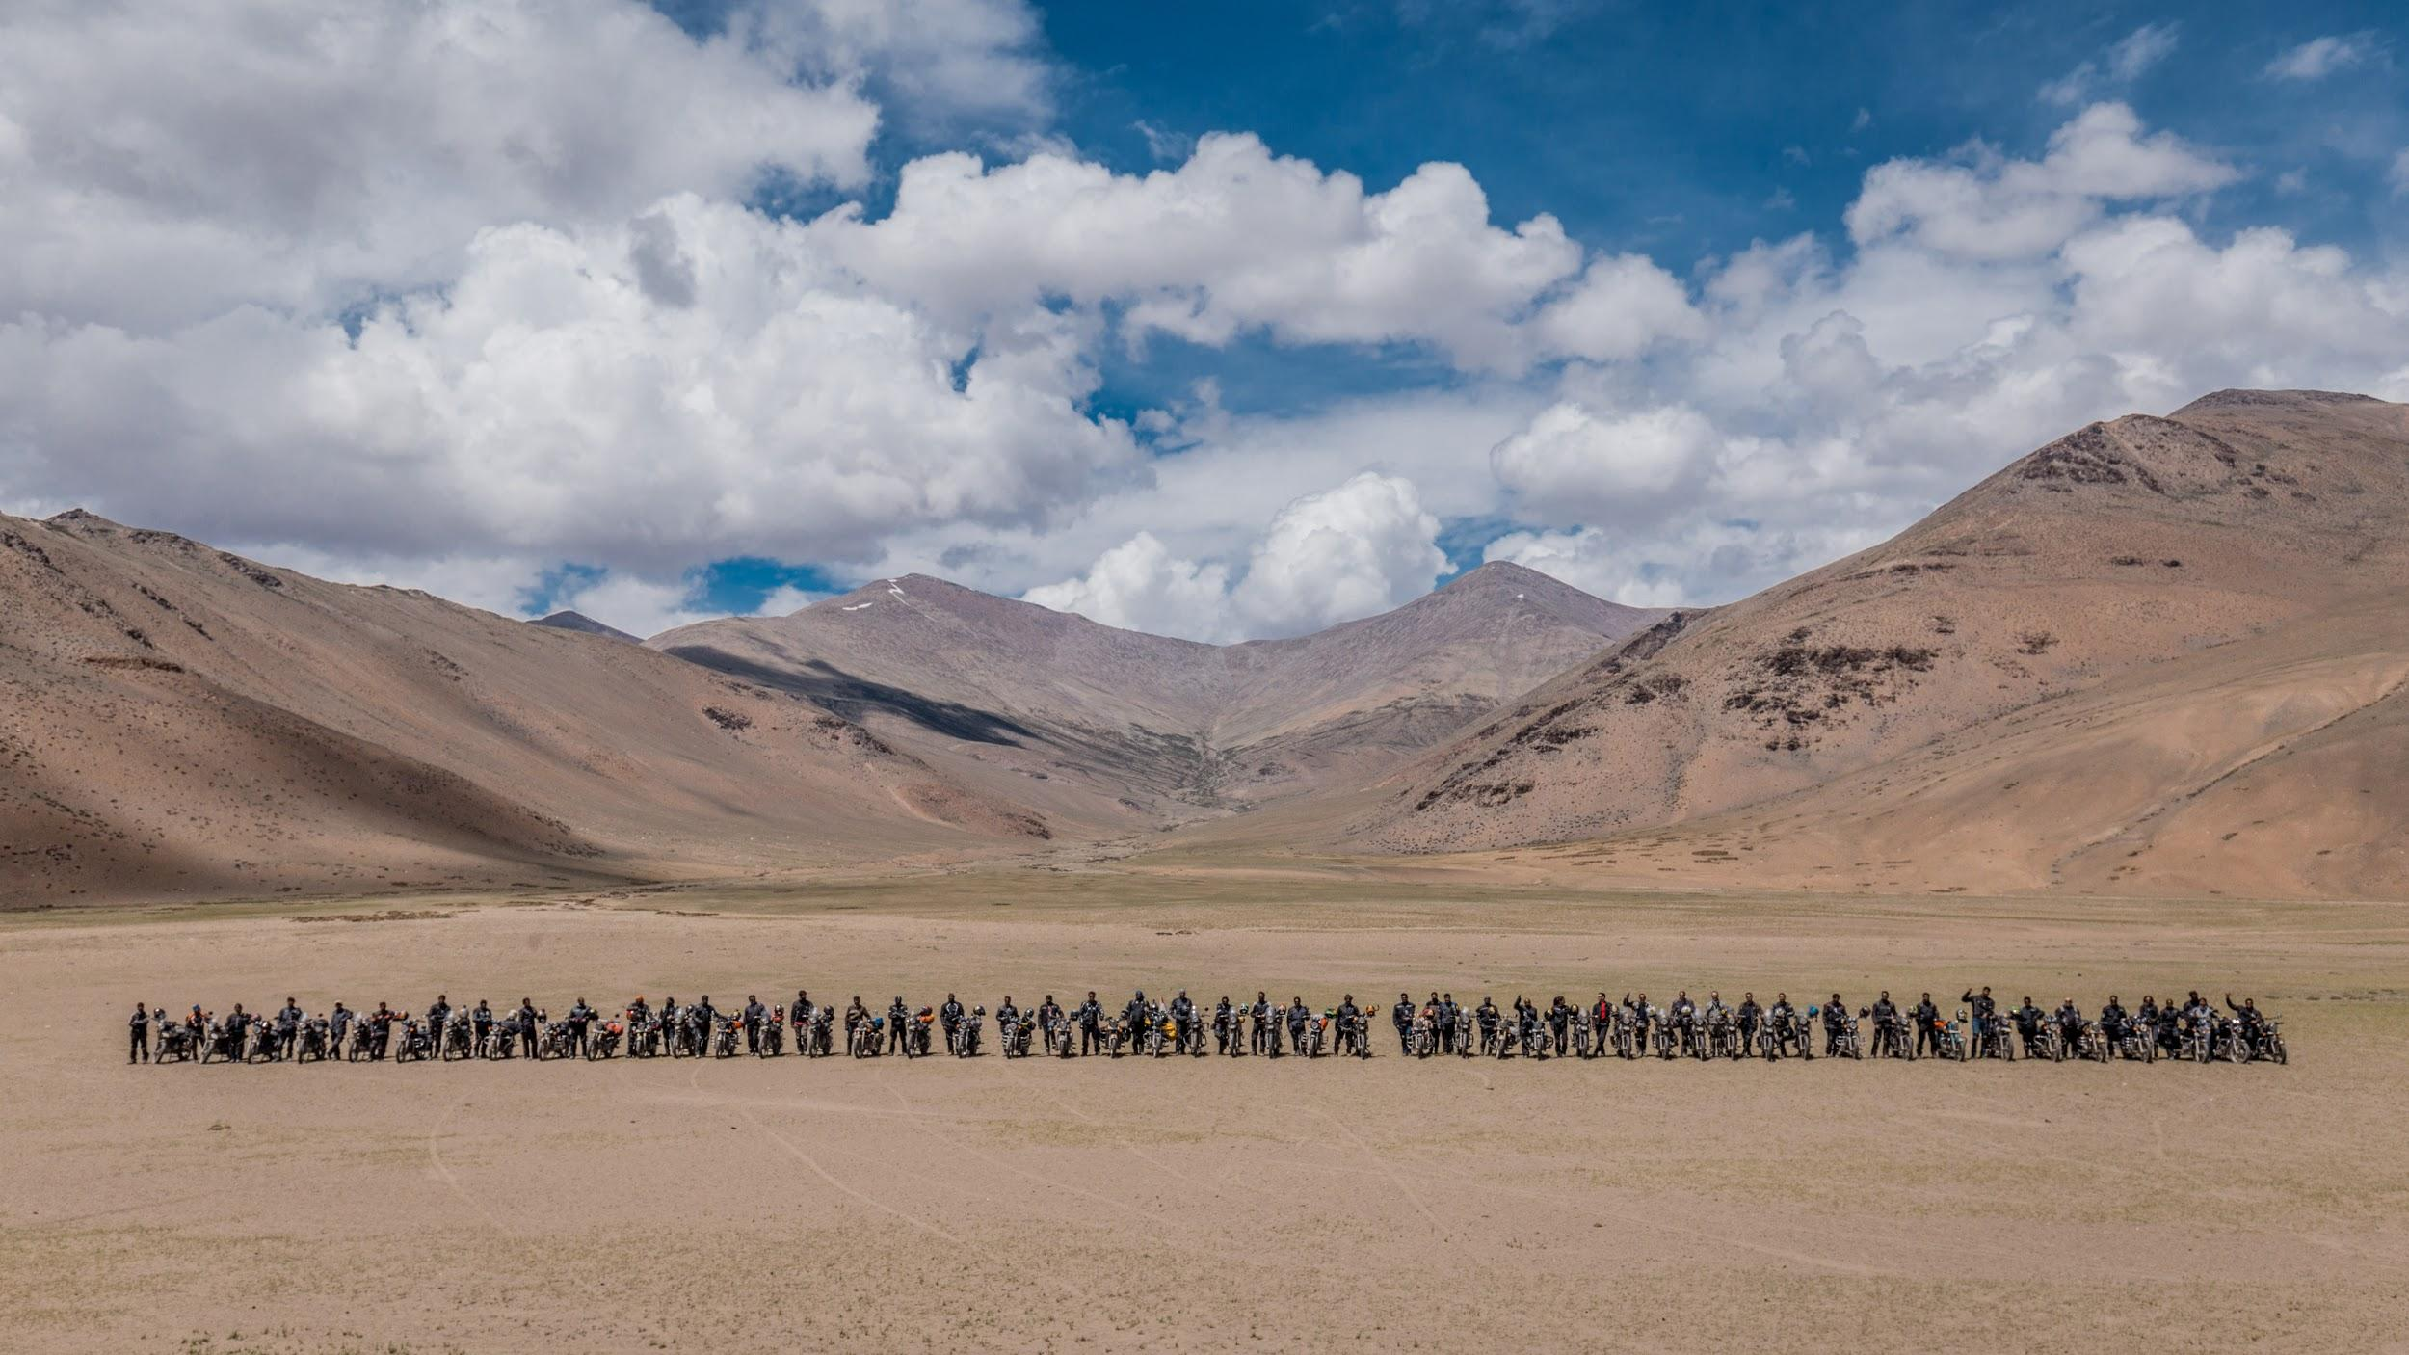

Himalayan Odyssey 2017 Images: Download

New Delhi, 1 May, 2018: Royal Enfield today announced the dates for the much awaited Himalayan Odyssey 2018. One of the biggest motorcycle ride of its kind in the world, Himalayan Odyssey will see participants traversing the mighty Himalayan terrain, covering a distance of close to 2, 200 kilometres in 18 days on their Royal Enfield motorcycles. To be held from July 5th to July 22nd, 2018, it will bring riders from across India together and provide them with unlimited supply of breathtaking views to intimidating terrain throughout the journey. Himalayan Odyssey has been the ultimate motorcycling ride in the Himalayas and will continue to challenge the riders at every step with numerous mountain passes and natural obstacles. A journey like Himalayan Odyssey is a life changing experience and over the 18 days, the riders will face each challenge together that will strengthen the sense of camaraderie amongst them and in the end leave every rider with memories which will remain deeply etched in the mind forever.

The 15th edition of the Himalayan Odyssey will be flagged off from India Gate, Delhi and traverse towards Khardung-La - the highest motorable road in the world at 17, 500 feet above sea level. The registrations will be open on the Royal Enfield website - www.royalenfield.com/ho for Himalayan Odyssey 2018 and Himalayan Odyssey - Women 2018 from May 4th onwards.

The Himalayas have been the mecca for motorcyclists and the Royal Enfield Himalayan Odyssey has been their chosen journey to ride through the mighty mountains. Royal Enfield is embarking on this epic journey with 50 participants on the Himalayan Odyssey and 20 women participants on the Himalayan Odyssey Women edition. Both the rides will be flagged off from Delhi together and will ride on different routes before finally converging at Leh. Through the ride, the participants will traverse across the picturesque regions of the Himalayas in Ladakh as well as Spiti. Both the regions will throw hostile challenges at the riders in terms of weather and terrain. Each turn will expose the riders to a new landscape like no other, eventually getting them surrounded by the overwhelming beauty of the great Himalayan peaks.

About Himalayan Odyssey

The Himalayan Odyssey is at the pinnacle of Royal Enfield’s philosophy of ‘Keep Riding Pure’ and the ‘motorcycling way of life’ and is considered to be one of the most aspirational motorcycle journey in the world. The 15th edition of Himalayan Odyssey pays tribute to Royal Enfield’s six-decade old legacy of riding in the lap of Himalayas, which it considers to be its spiritual home.

Himalayan Odyssey provides its riders with a larger than life, authentic riding experience under guidance from experienced ride leaders and support staff.

To know more about #Himalayan Odyssey 2018 visit: www.royalenfield.com/ho

Route of Himalayan Odyssey 2018

HIMALAYAN ODYSSEY 2018
Delhi * Chandigarh * Manali * Leh * Keylong * Kaza * Kalpa * Narkanda * Chandigarh.
Sr. No | DAY | DATE | SECTOR | Distance (KM)
0 | Thur | 05-Jul | Check In Del | -
1 | Fri | 06-Jul | Briefing - Delhi | -
2 | Sat | 07-Jul | Delhi to Chandigarh | 256
3 | Sun | 08-Jul | Chandigarh to Manali | 310
4 | Mon | 09-Jul | Manali to Keylong | 116
5 | Tue | 10-Jul | Keylong to Sarchu | 107
6 | Wed | 11-Jul | Sarchu to Leh | 260
7 | Thur | 12-Jul | Leh | -
8 | Fri | 13-Jul | Leh to Hunder | 128
9 | Sat | 14-Jul | Hunder to Leh | 128
10 | Sun | 15-Jul | Leh to Debring | 170
11 | Mon | 16-Jul | Debring to Keylong | 230
12 | Tue | 17-Jul | Keylong to Kaza | 186
13 | Wed | 18-Jul | Kaza | -
14 | Thur | 19-Jul | Kaza to Kalpa | 206
15 | Fri | 20-Jul | Kalpa to Narkanda | 168
16 | Sat | 21-Jul | Narkanda to Chandigarh | 174
17 | Sun | 22-Jul | Checkout | -
 |  |  | Total | 2439

Route of Himalayan Odyssey Women 2018

HIMALAYAN ODYSSEY - Women's Edition 2018
Delhi * Parwanoo* Narkanda * Manali * Leh * Jispa * Manali* Gushani * Chandigarh.
 | DAY | DATE | SECTOR | Distance (KM)
0 | Thur | 05-Jul | Check In Del | -
1 | Fri | 06-Jul | Briefing - Delhi | -
2 | Sat | 07-Jul | Delhi to Parwanoo | 240
3 | Sun | 08-Jul | Parwanoo to Narkanda | 158
4 | Mon | 09-Jul | Narkanda to Manali | 209
5 | Tue | 10-Jul | Manali | -
6 | Wed | 11-Jul | Manali to Tandi | 110
7 | Thur | 12-Jul | Tandi to Sarchu | 113
8 | Fri | 13-Jul | Sarchu to Leh | 260
9 | Sat | 14-Jul | Leh | -
10 | Sun | 15-Jul | Leh to K'Top to Leh | 80
11 | Mon | 16-Jul | Leh to Tso Moriri | 220
12 | Tue | 17-Jul | Tsomoriri to Tsokar | 90
13 | Wed | 18-Jul | Tsokar to Jispa | 203
14 | Thur | 19-Jul | Jispa to Manali | 107
15 | Fri | 20-Jul | Manali to Gushaini | 95
16 | Sat | 21-Jul | Gushaini to Chandigarh | 201
17 | Sun | 22-Jul | Check Out | -
 |  |  | Total | 2086

About Royal Enfield

The oldest motorcycle brand in continuous production, Royal Enfield made its first motorcycle in 1901. A division of Eicher Motors Limited, Royal Enfield has created the mid-sized motorcycle segment in India with its unique and distinctive modern classic bikes. With its new manufacturing base in Chennai, India, Royal Enfield is able to grow its production rapidly against a surge in demand for its motorcycles. With more than 50% growth every year for the last 5 years, Royal Enfield is fast becoming a very important player in the global mid-size motorcycle market and is working towards re-inventing this space with motorcycles that are evocative and engaging and great fun to ride.

Royal Enfield’s product line‐up in India includes the Bullet, Classic and Thunderbird and Thunderbird X models in 350 and 500cc displacement along with purpose-built Himalayan powered by the new LS410 engine. Royal Enfield operates through 17 company-operated stores and 750+ dealers in all major cities and towns in India, and exports to over 50 countries across the world including the USA, UK, several European and Latin American countries, as well as the Middle East and South-East Asia. Royal Enfield also organizes and supports many motorcycling events and rides globally, more prominently the Rider Mania – an annual gathering of Royal Enfield riders from all over the world to the lovely beaches of Goa, and the Himalayan Odyssey, the most arduous motorcycle ride over some of the toughest roads and highest mountain passes in the Himalayas. Royal Enfield also conducts the popular ‘One Ride’ where people around the world ride out on their motorcycles on the first Sunday of April.

To know more about Royal Enfield, the motorcycles, marquee rides and other initiatives, visit:
http://royalenfield.com
Be a part of one of the largest communities of motorcycling enthusiasts; like Royal Enfield on Facebook
https://www.facebook.com/RoyalEnfield; Follow @RoyalEnfield on Twitter

For further information, please contact:
Shreyas Bhatt: shreyas@eichermotors.com
Priyanka Koijam: koijam.priyanka@royalenfield.com
Nikita Verma – nikita.verma@bm.com

