DIRT TRACK 2025
Motoverse 2025 - Dirt Track
Gear up for three days of high-octane dirt racing! Experience new classes, fierce competition, and pure Royal Enfield spirit only at Motoverse’s ultimate Motothrill.
Motoverse 2025 - Dirt Track Race Rules
The event will be held under International Sporting Code of the Federation Internationale de Motocyclisme (FIM) for 2 wheelers and appendices of The Federation of Motor Sports Clubs of India (FMSCI).
Dirt Track Classes
- Class 1: 650-cc - Men Elite: Group A
- Class 2: 650-cc - Men Novice: Group A
- Class 3: Women’s Class - Any RE Motorcycle: Group A
- Class 4: 500 to 550-cc - Men Elite: Group A
- Class 5: 500 to 550-cc - Men Novice: Group A
- Class 6: Scram 440/OG 411 - Men Elite: Group A
- Class 7: Scram 440/OG 411 - Men Novice: Group A
- Class 8: First Timers: Group A
- Class 9: Himalayan 450 - Men Elite: Group A
- Class 10: Himalayan 450 - Men Novice: Group A
- Class 11: 350-cc - Men Elite: Group A
- Class 12: 350-cc - Men Novice: Group A
- Class 13: Enduro Club League: Group A
- Class 14: Race of Champions - Open only for previous Dirt Track race winners from Rider Mania/Motoverse (2009-2024)

Please find the draft of Supplementary Regulations for the event can be downloaded here
Classes Definition:
Novice - Riders who have not podiumed in the past editions of Rider Mania/Motoverse, across all classes of Dirt Track (2009-2024). Please note: a Novice rider is allowed to participate in the Elite class.
Elite - Riders who have podiumed in the past editions of Rider Mania/Motoverse in Dirt Track (2009-2024). Please note: an Elite rider will not be allowed to participate in the Novice class.
First Timers - Riders who have never participated in any officially recognized dirt race or dirt track event in India. Please note: a First Timer is allowed to participate in Elite and Novice class.
Women’s Class - Open for all women riders on any Royal Enfield motorcycle.
Enduro Club League - A high-octane relay race where three riders from each motorcycle club take turns racing laps on the track. Each rider completes their laps, parks, and runs to hand over their bike key to the next teammate. The race continues until all team members finish, testing speed, strategy, and teamwork.
Only one team from each group is allowed to take part in the event.
*on spot registration before day 1, 6 pm

Race of Champions - Exclusively open for previous Dirt Track race winners of the festival (2009-2024)
*on spot registration before day 1, 6 pm

Note for Class 6 and Class 7: Both motorcycles (Scram 440/Himalayan 411) will compete together in Scram 440 / OG 411 class.
RULES AND REGULATIONS
Entry Procedure
- Please note you can take part in multiple Dirt Track Classes under above Class list in Motoverse 2025 - Dirt Track.
- FMSCI Competition licence form FMSCI. This requires at least 1 working day to be issued. Please do this in advance to avoid last minute challenges.
- Entry fee for Dirt Track classes Rs. 1499/- per class (Exclusive of FMSCI licence fee)

The above mentioned charges would be charged per class for the Dirt Track event and can be paid online or at the event area. Participants will also get a Jersey.

Note: Participants holding a valid FMSCI Licence (2W Club Sport Others - Closed, Closed Invitation and Open Status) are requested to carry their original RTO licence along with photocopy for documentation.

Documents Required at Arena
- Original RTO-issued Driving Licence (Motorcycle with gear - MCWG) to be submitted at the venue for verification.
- Indemnity Form to be filled, signed, and submitted at the venue.
- Birth Certificate/Adhaar Card/ PAN Card
- FMSCI License

Entries Closure
- Entries close for all 650-cc - Men, Women's Class and 500 to 550-cc - Men classes at 12:00 PM on 21 Nov 2025 at the Dirt Track arena.
- Entries close for all other classes at 06:00 PM on 21 Nov 2025 at the Dirt Track arena.

Pre-Event Scrutiny
- Pre-race scrutiny is compulsory for all competing motorcycles.
- Post scrutiny, competitors are not allowed to make alterations to the competing motorcycle.
- Motorcycles which might affect the vehicle's classification or safety without the written consent of the Clerk of the Course will be disqualified. On completion of scrutiny, competitors will be given a ‘Number Poncho’ which must be worn in a manner so as to be clearly visible for observation and must be displayed to the paddock marshal before practice, qualifying, and race sessions.

TECHNICAL SPECIFICATIONS
- Modifications according to Group A specifications of the FMSCI.
- Bridge handlebar is allowed.
- Exhaust, Carburettor,Fuel Injection System, and Air Filter are Free.
- Fibre-made front and rear mudguards are allowed.
- Accessories, chain cover, crash guard, saree guard, side stand, main stand, headlight, indicators, tail-lamp and mirrors have to be compulsorily removed before the pre-race scrutiny.
- Fuel tank should be original production-spec (unmodified) Royal Enfield OEM fuel tank is allowed as per the registered model.
- No suspension modifications are allowed, only original production suspension of motorcycle entered are allowed.
- No change in chain sprockets are allowed , only original production chain sprockets of motorcycles allowed as per the same model registered.
- Only Standard OEM Rim Sizes are allowed of the motor as per the same model registered.

TYRES ALLOWED AT THE EVENT
- Only the below mentioned tyres will be allowed in the Dirt Track Competition.
- All Royal Enfield OEM Tires
- Michelin Sirac
- Ceat Tyres
- Dunlop Unigrip
- Dunlop Monster Trail
- MRF Meteor
- MRF Moto D
- MRF Moto C
- Ralco Tyres
- Timsun Tyres - 90/90 - 21
- Timsun Tyres - 130 /90 - 17
- Timsun Tyres - 90 /90 - 19
- Timsun Tyres - 110/80 -18
- Timsun Tyres - 120/80 - 18
- Pirelli SCORPION RALLY STR 90/90 - 21
- Pirelli SCORPION RALLY 150/60 R 17
- MRF Nylorex tyres – 100/90-19
- MRF Nylorex tyres – 140/80 R17
- Off Road / Knobby / Motocross tyres will not be allowed, only Street Legal tyres will be allowed apart from the above mentioned List.

RIDING GEAR REQUIREMENTS:
- HELMETS ARE COMPULSORY. These should be Full Face, one piece (Non Modular), either of ISI or International Standards (DOT/Snell). These should be in a sound condition and fitted properly with Strap. However, the scrutineer will decide on the race worthiness of any helmet.
- Calf length or ankle length leather boots are compulsory.
- Wearing of shin guard and knee guards are mandatory.
- Full length leather gloves / gloves of durable material in sound condition are compulsory.
- Goggles/Spectacles are Compulsory & must be splinter proof or non - inflammatory.
- Riding gear of thick cord / denim is compulsory. Dress regulations should be strictly adhered to during practice, in paddocks and during the race. Violation entails Compulsory EXCLUSION.

OFFICIAL PRACTICE
Official practice sessions will be held for all classes as per programme.

OFFICIAL QUALIFYING HEATS & ELIMINATION ROUNDS
Official qualifying sessions will/may be held for all classes provided the numbers of entries justify elimination. Qualifying sessions for the event will be held immediately after practice at the venue. In such classes which have the stipulated number of entries and it is decided by the organizers that elimination need not be done, qualifying sessions may not be held.
Qualifying procedure: Elimination heats will be conducted. The top 8 will proceed to the next round.
RIDER’S BRIEFING MEETING
A rider’s briefing meeting will be held as per programme. It is mandatory for all competitors to attend the briefing meeting, practice and qualifying sessions. An attendance register will be maintained for the meeting and all other sessions wherein the competitors need to sign. Absence may result in EXCLUSION.
COMPETITION NUMBERS
- All riders will be given competition numbers in the form of ponchos and Number stickers, after their vehicle has cleared pre-event scrutiny. Ponchos are vests which bear the competition number of each rider on the front and back with an advertiser’s message. Competitors must wear these ponchos at all times beginning from practice till the end of the event. Loss of the same will entail a fine of Rs.100/- or the rider may not be allowed to start in his class.
- The organizers will also give three competition number stickers. These are to be compulsorily displayed One on the front and two on the sides of the vehicle.
- Ponchos and Competition numbers must be displayed prominently on the body of the rider and his vehicle. Neither must be displayed in such a manner that they are not clearly visible or obscured by any part of the rider or the machine. Failure to display these ponchos or stickers may entail a penalty of Rs.100/- for the start and may lead to exclusion. The onus of ensuring that these are clearly visible lies entirely with competitors.

STARTING PROCEDURE
The start will be a mass start with engines running and clutch engaged. The chief starter will hold up a red flag until all riders are on the starting grid. Gate / Flag start will be given using 15 and 5 seconds Board. The race will start as soon as the Gate / Flag drops.

FALSE START
If the start line marshal decides that the start of the race is not in accordance with the above procedure, he/she will immediately wave the Red Flag. All competitors shall return immediately to the start line/gate and be ready for the starting procedure again. The start line marshal on the first infringement will warn competitor/s taking a FALSE START. If the competitor/s commits a second infringement he/they will be started from a line, which is at least 3 meters behind the Start Line.

FINISH PROCEDURE
The chequered flag will drop as the winner finishes the race. It will be held stationary for a period of time thereafter to enable all competitors who follow the winner to complete the lap they are on. Each competitor crossing the Finish line after the winner will be flagged in and placed. Firstly according to the number of laps completed, and when more than one competitor has completed the same number of laps, in the order in which they have completed their last lap.

FAQs:
Q) Do I need a FMSCI License to participate in Dirt Track?
A) Yes, you do need a FMSCI (2W Club Sport Others) license.

Q) Can I participate in multiple classes?
A) Yes, you can take part in multiple classes if you meet the eligibility criteria.

Q) When does offline registration start?
A) The offline registrations for all the classes would also start from 20th Nov from 1330 hrs to 1730 hrs. The slots are subject to availability.

Leaderboard
A rider will be awarded certain points for participating and securing position in the event. If He/She represents any CLUB, the points secured by the rider would also be added in their CLUB point also. At the end of the event, the rider and club with maximum points wins.
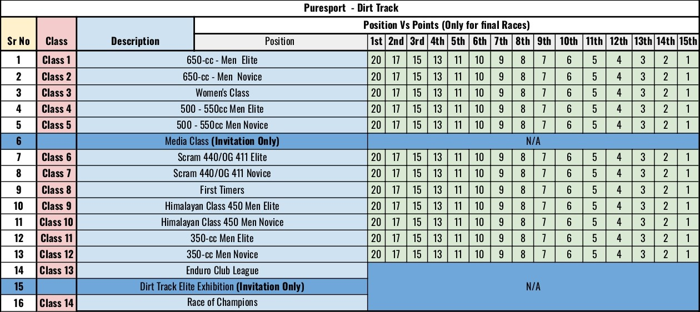
*The Leaderboard is not applicable for Class 13 and Class 14
Organizers reserve the right to add prizes to the above mentioned list.

